IS 312: Web Design and Programming
PE02: Programming Exercise

Objective: Create a resume page to add to your portfolio

- Open PE02 in a code editor. If you would like to work in code spaces, you will need to create a new repository called PE02. Then add the index.html and styles.css to the repo. Next click the green code button and create a Codespaces.

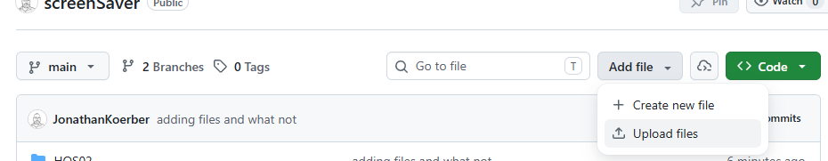
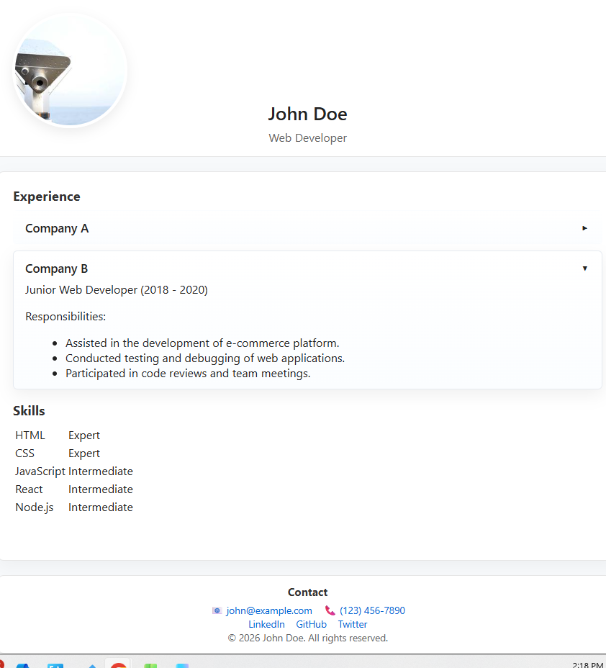
- Next for the root directory run ‘python3 -m http.server 8000’ to look at the what you have. It should look something like the screen shot here. No got into the code and use this as starter code to build your resume page by adding an appropriate picture, your name work history, skills and education. Update the color scheme. When you come to the skills refer to the HOS and this link to style the table.
- Find a simple way to apply the accordion action to the Skills section.
- Create an education section. That also has an accordion action.

Submission:
Summarize what you have done on a Word Doc.
- Add a screen shot of your page with all the changes that you made.
- Answer the following:
  - How did you decide to implement your color scheme
  - What challenges did you run into styling the skills table.
Add your summary and files to Brightspace.

